Assuming Tables:
CUSTOMERS : CustomerID, Name, Age, Balance, IsVIP
LOANS : LoanID, CustomerID, InterestRate, DueDate

Scenario 1:
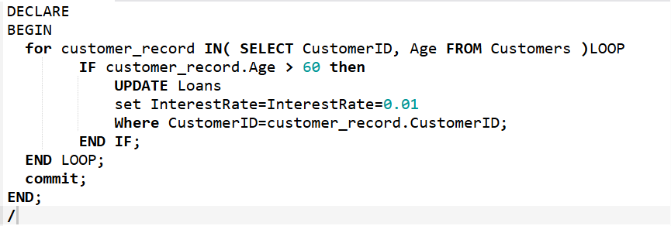
Scenario 2:
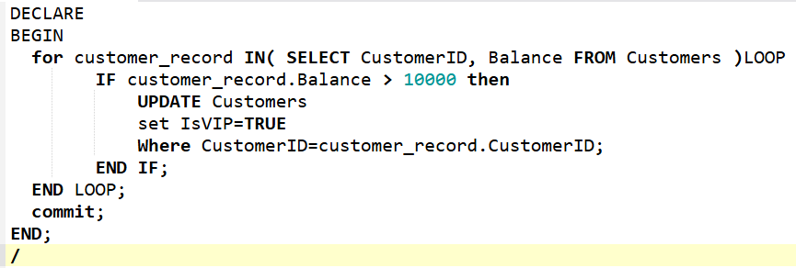
Scenario 3:
